Department of Community Medicine

Practical note Book

- RFST Report
- Survey on knowledge and practice of rural mothers regarding ante- natal care in two villages of golapgonj upozila, sylhet.

Batch- SWMC- IV
Reg. No: ----------------------------
Session: -----------------------------
Code No: ---------------------------

Sylhet Women’s Medical College
Mirboxtula, Sylhet

A survey on
Knowledge and Practice of Rural Mothers Regarding Ante-natal Care in Two Villages of Golapgonj Upozila.

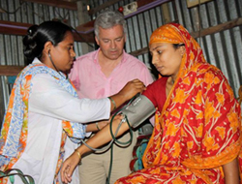

ANNEXURE

